Images / Multimedia

Definition:
# Source: AI Source: Provided by: [Data Path: Persons Table -> ID Column: 1, Name_En Column: Motasem Essam] -> From: [Chatgpt (GPT‑5 Mini)] on [2/12/2026]
Images / Multimedia are web page components that provide visual or audio content to make a web page more engaging and informative. They support the main content and help communicate ideas more effectively.

Simple Definition
# Source: AI Source: Provided by: [Data Path: Persons Table -> ID Column: 1, Name_En Column: Motasem Essam] -> From: [Chatgpt (GPT‑5 Mini)] on [2/12/2026]
Images / Multimedia = pictures, videos, animations, or audio used on a web page to enhance content and user experience.

What Images / Multimedia Usually Includes
# Source: AI Source: Provided by: [Data Path: Persons Table -> ID Column: 1, Name_En Column: Motasem Essam] -> From: [Chatgpt (GPT‑5 Mini)] on [2/12/2026]
- Images – photos, illustrations, icons, logos
- Videos – tutorials, product demos, background videos
- Audio / Music – podcasts, sound effects, voiceovers
- Animations / GIFs – to highlight content or attract attention
- Slideshows / Carousels – multiple images or content displayed in rotation

Purpose of Images / Multimedia
# Source: AI Source: Provided by: [Data Path: Persons Table -> ID Column: 1, Name_En Column: Motasem Essam] -> From: [Chatgpt (GPT‑5 Mini)] on [2/12/2026]
- Make content visually appealing
- Help explain or demonstrate ideas clearly
- Capture user attention and engagement
- Break up large blocks of text for better readability

Examples
# Source: AI Source: Provided by: [Data Path: Persons Table -> ID Column: 1, Name_En Column: Motasem Essam] -> From: [Chatgpt (GPT‑5 Mini)] on [2/12/2026]
- E-commerce → product images and 360° product videos
- Blog → images in articles or tutorial videos
- Portfolio → photos of work or design projects
- Educational site → diagrams, infographics, and instructional videos

Difference Between Main Content and Images / Multimedia
# Source: AI Source: Provided by: [Data Path: Persons Table -> ID Column: 1, Name_En Column: Motasem Essam] -> From: [Chatgpt (GPT‑5 Mini)] on [2/12/2026]
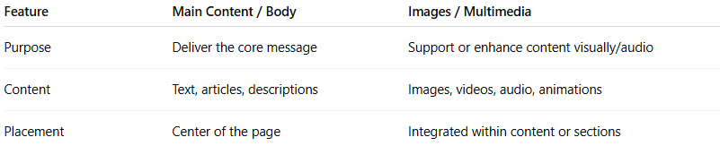
Feature | Main Content / Body | Images / Multimedia
Purpose | Deliver the core message | Support or enhance content visually/audio
Content | Text, articles, descriptions | Images, videos, audio, animations
Placement | Center of the page | Integrated within content or sections

